Partner | Logo | Brief information | Participant / or Contact Person
Riga Technical University (RTU)  www.rtu.lv |  | Riga Technical University is the first technical university in the Baltic countries – its history dates back to 1862 when Riga Polytechnic was founded. RTU is accredited, internationally recognized European university that consists of 8 faculties and 35 institutes. It is the second largest university in Latvia by number of students, and it has the greatest number of state funded students. | Sandris Grantins  Riga Technical University  Office of Vice-rector for Research  HPC Project manager  e-mail: Sandris.Grantins@rtu.lv
KTH Royal Institute of Technology  www.kth.se |  | KTH in Stockholm is the largest, oldest and most international technical university in Sweden. No less than one-third of Sweden’s technical research and engineering education capacity at university level is provided by KTH. Education and research spans from natural sciences to all the branches of engineering and includes architecture, industrial management and urban planning. The educational programmes lead to Bachelor, Master or PhD degrees in engineering, science, or architecture. There are a total of almost 14,000 undergraduate students and more than 1,700 active postgraduate students. KTH has just over 4,600 employees. | Lennart Johansson  Project Manager International Projects  e-mail: lennartj@admin.kth.se
Aerohive  www.aerohive.com |  | Aerohive Networks reduces the cost and complexity of today's networks with cloud-enabled Wi-Fi and routing solutions for medium and large enterprise headquarters, branch offices and teleworkers. Aerohive’s award-winning cooperative control Wi-Fi architecture, public or private cloud-enabled network management, routing and VPN solutions eliminate costly controllers and single points of failure. This gives its customers mission critical reliability with granular security and policy enforcement and the ability to start small and expand without limitations.  The confluence of the “iEverything” mobility explosion, the emergence of Wi-Fi as the primary network access technology, the efficiencies of cloud services, and the decentralization of the corporate office, with home-shoring, teleworkers, micro-branches and partnering, is forcing enterprises to reevaluate their IT strategies. Aerohive’s vision securely harnesses these trends and technologies to enhance enterprise productivity, while at the same time, reducing the cost and complexity of today’s networks.  Aerohive is able to achieve this vision by delivering:  - Productive Mobility  - Distributed intelligence for enhanced visibility and control of wireless clients  - Mission-critical reliability without bottlenecks or single points of failure  - Granular policy enforcement to secure and control consumer devices that connect to the enterprise network  - Cloud-enabled Networking  - Leveraging the scale, availability and economies of the cloud to minimize network provisioning complexity and operational cost  - Reduce capital expense with “Software as a Service” management options  - Extended enterprise networking  - Headquarters–like access, security, and performance at any location  - Cost effective, enterprise class, branch and teleworker infrastructure  - Survivable, self organizing / self healing network OS | Roger Kervén  Sales Director Nordic & Baltic  e-mail: roger@aerohive.com  Mob.: +46 73 517 7002
Baltic HPC Association  www.baltic-hpc.ru | 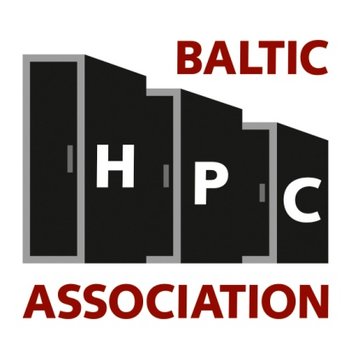 | Baltic HPC Association is a non-profit organization and the objective of the association is to facilitate the development of high performance computing (HPC) technology and implementation in Baltic sea region countries. | Ruslans Dudkins  Head of Communication Infrastructure Department  (Komunikācijas infrastruktūras nodaļas vadītājs)  e-mail: Ruslans.Dudkins@rtu.lv
Baltic ScanTech  www.balticscantech.com |  | The Scan Tech provides the systems, software and services to leverage one of your most strategic assets - your business data.  Our goal is to optimize your information infrastructure to meet growing demands for enterprise content management, security, archiving, storage, and Infrastructure virtualization, testing and measurement. | MS.c(eng) Mahmoud Rostampour  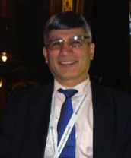  Managing Director of ScanTech Baltic, Cisco SMB System Engineer&Account Manager, Microsoft Cloud Partner, CSP Adobe in Stockholm, Sweden  More information:  http://www.linkedin.com/mahmoud-rostampour  e-mail: mahmoud.rostampour@balticscantech.com  mob. +468373995
Combinova AB  www.combinova.se |  | Combinova AB is representing the Taiwanese company in Sweden and Latvia. The full name is Chroma ATE Inc. Combinova AB has a long tradition within testing and measurement.  For more than 25 years, we have been manufacturing our own instruments for measuring electric and magnetic fields. Our instruments are used to verify compliance with limits stated in international standards for labelling criteria and to investigate fields around power lines or at workplaces. | Åke Amundin  CEO at Combinova AB  e-mail: ake.amundin@combinova.se  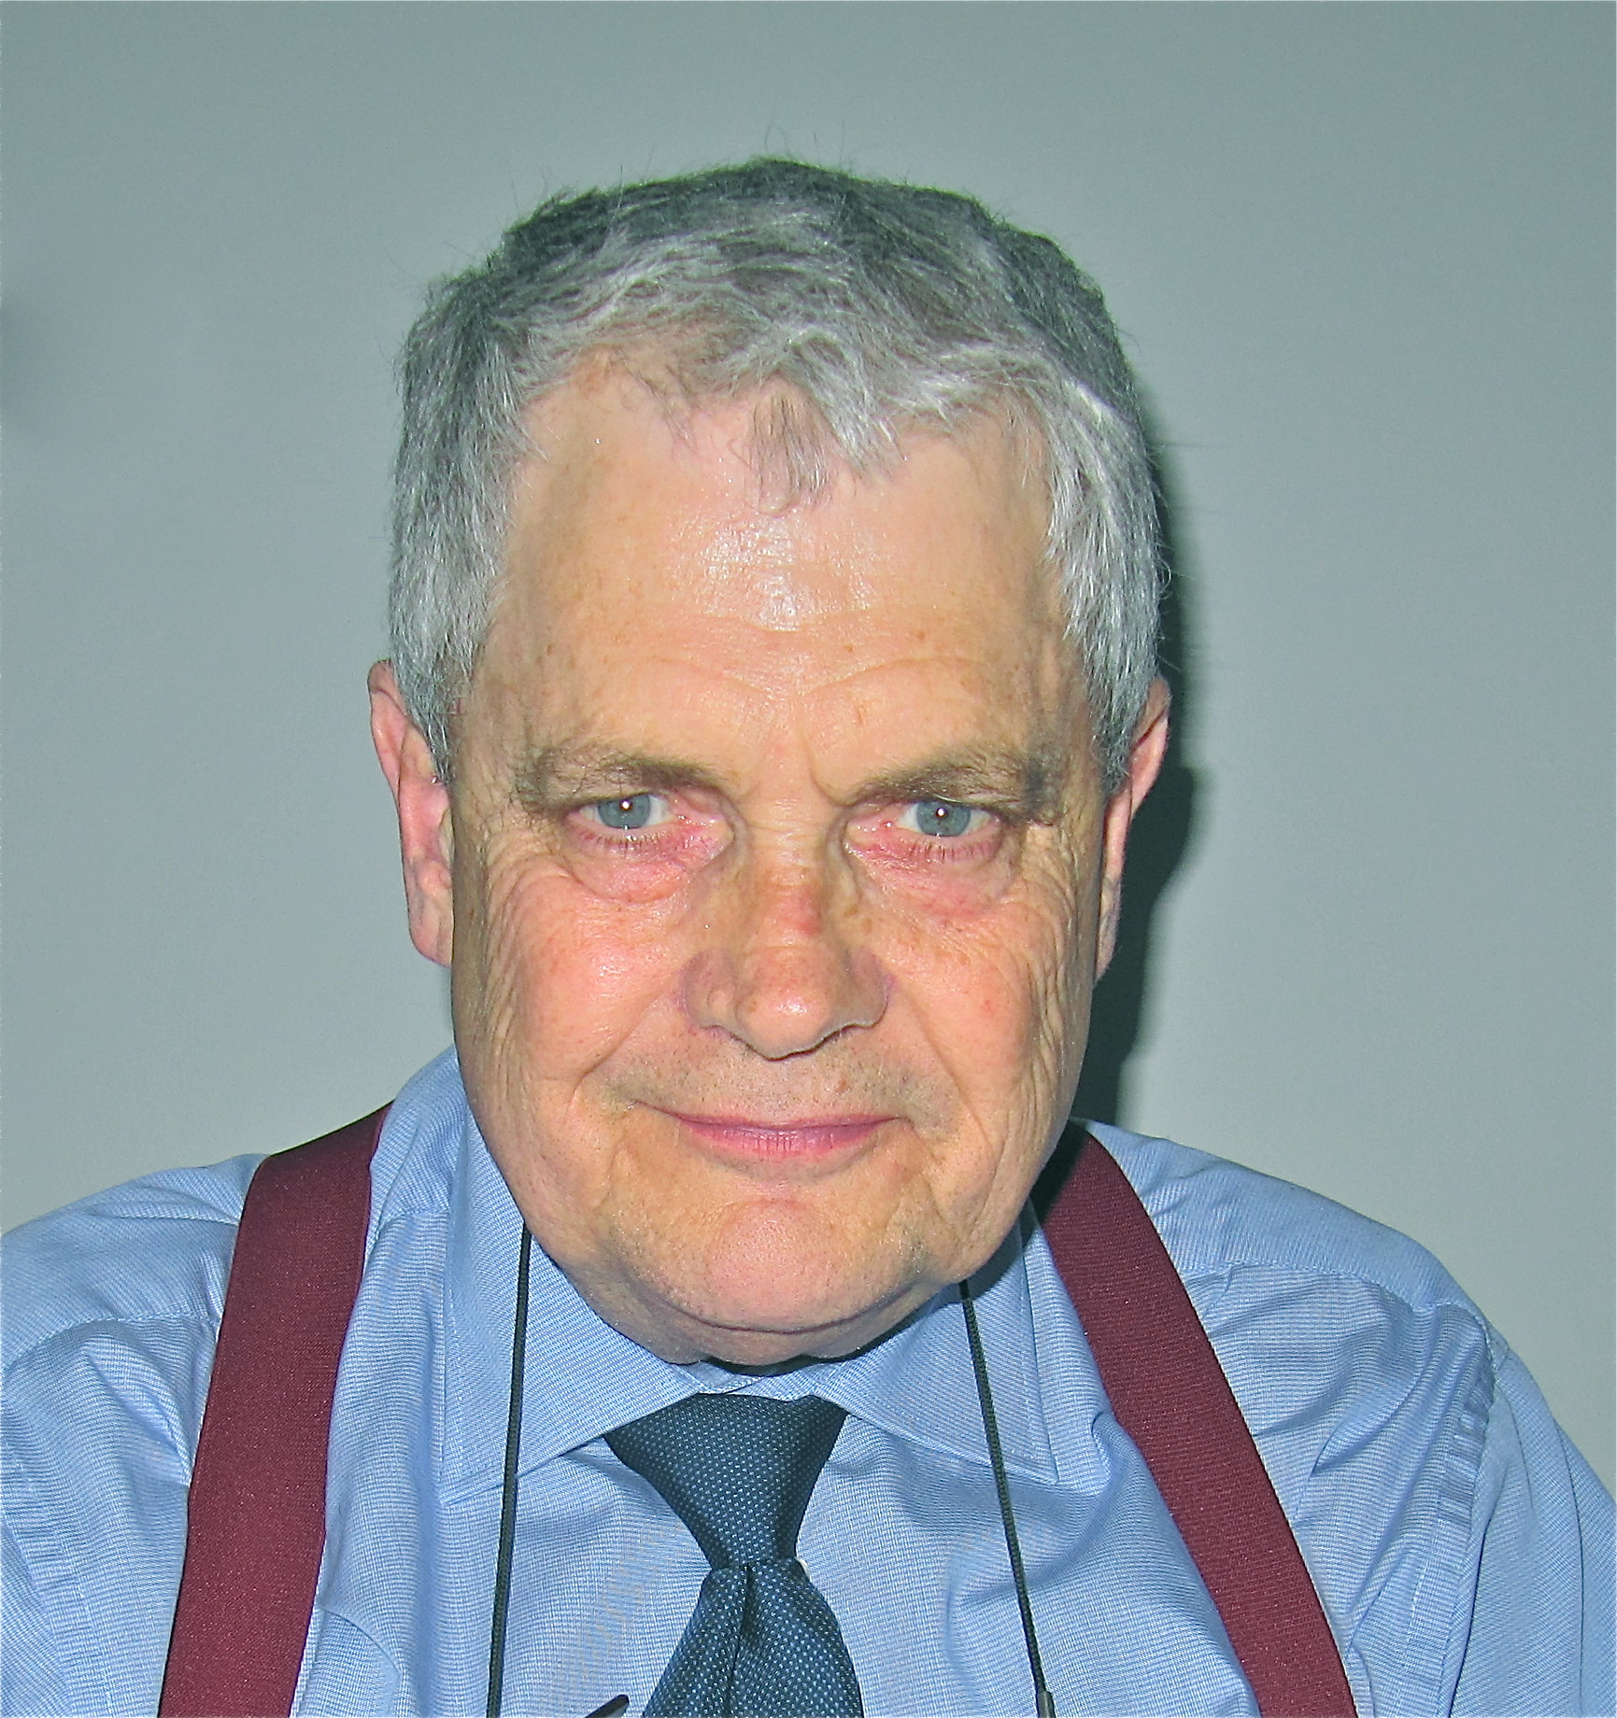
Fujitsu  ts.fujitsu.com |  | Fujitsu is the leading Japanese information and communication technology (ICT) company offering a full range of technology products, solutions and services. Over 170,000 Fujitsu people support customers in more than 100 countries. We use our experience and the power of ICT to shape the future of society with our customers. Fujitsu Limited (TSE:6702) reported consolidated revenues of 4.5 trillion yen (US$54 billion) for the fiscal year ended March 31, 2012.  About Fujitsu Technology Solutions  Fujitsu Technology Solutions is the leading European IT infrastructure provider with a presence in all key markets in Europe, the Middle East and Africa, plus India, serving large, medium-sized and small businesses. The company offers a full portfolio of IT products, business solutions and services, ranging from workplace systems to datacenter solutions, managed services, and cloud-based software and solutions. Fujitsu Technology Solutions employs more than 13,000 people and is part of the global Fujitsu Group. For more information, please see: ts.fujitsu.com/aboutus  Fujitsu in HPC  http://www.fujitsu.com/fts/products/computing/servers/primergy/performance/ | Antti Vari  Channel Business Manager  The Baltic States  e-mail: antti.vari@fi.fujitsu.com  Mob.: +372 502 6227
Violin Memory  http://www.vmem.com |  | Violin Memory is pioneering the future of flash storage in the enterprise data center. Violin flash Memory Arrays deliver storage at the speed of memory, accelerating business critical applications and enabling fully virtualized and optimized IT infrastructures. Designed for sustained performance with high reliability, Violin flash Memory Arrays scale to hundreds of terabytes and millions of IOPS with low, spike-free latency.  Founded in 2005, Violin Memory is headquartered in Mountain View, California. At the heart of our flash Memory Arrays lies the switched memory fabric developed and patented by our founder, Jon Bennett. With an established leadership bringing experience and success from many industry pioneering companies, Violin is well positioned to lead the next generation of enterprise storage | Morten Efferbach  Nordic Sales Director  e-mail: mefferbach@vmem.com  M: +4540739020

