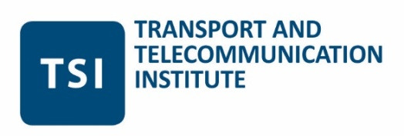

ACTUAL PROBLEM OF EDUCATION (MIP-2017) – INTERNATIONAL SCIENTIFIC AND EDUCATIONAL CONFERENCE
1-2 June, 2017
Riga, Latvia

MEETING INFORMATION

Host: TTI -Transport and Telecommunication Institute
1 Lomonosova Street
LV-1019, Riga,
LATVIA
Contacts:

Contact person:

Ms. Juta Starčenko
Phone: (+371)67100651
E-mail: MIP@tsi.lv

By public transport (15 minutes from City Center):
- by trolley-bus No. 15 to Lomonosova Street stop
- by tram No. 7 or 9 to Balvu Street stop
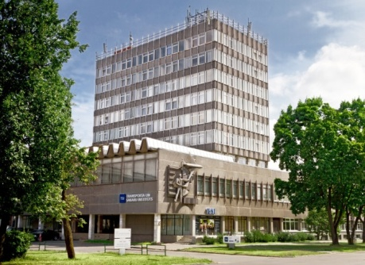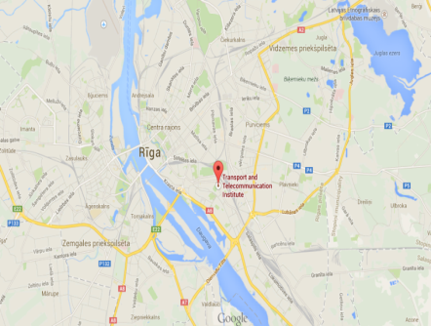
City Center

How to reach Riga City Center from the Riga Airport

By bus
- There is a direct bus from the airport (stop: Lidosta Riga) to Riga City Centre (stop: Stockmann centrs or Centraltirgus) - Bus Nr. 22.
- In the airport you walk straight out at the terminal on the 1st level. To get the bus at the Airport please look for bus stop located opposite the terminal behind the car park P1 (please see the image below)

- You can find the bus schedule at the stop by following the link (frequency 10-30 minutes):
www.rigassatiksme.lv
- Regular ticket for one trip can be bought from the bus driver for 2.00 EUR, but if you buy it before starting your trip at the Airport services and tourism information bureau "Welcome to Riga", a regular one-way ticket will cost you only 1.15 EUR
- Journey time to city centre about 30 minutes.

By taxi
- We recommend you to use a Baltic Taxi (green one)
- In the Baltic Taxi you can pay by cash or by credit card
- Average cost to reach the City Centre from the airport is around 15 EUR
Hotels: BELLEVUE Park Hotel Riga****
1Slokas Street, Riga, Latvia
Phone: +371 67069053, Fax: +371 67069001
E-mail: reservations@bellevue.lv
http://www.hotelbellevue.lv/en
Special rate: 40.00 € (single room per night, breakfast, VAT and fitness club included)
For registration, please use booking code: TSI
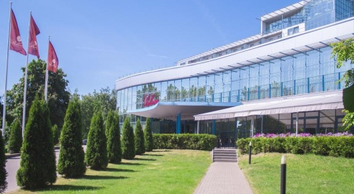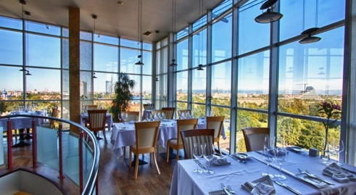

Rixwell Old Riga Palace Hotel ****
8/10 Minsterejas Street, Riga, Latvia
Phone: +371 67559791, Fax: +371 67791604
Contact person: Aleksandrs Elsbergs
E-mail: aleksandrs.elsbergs@mogotel.com
http://www.rixwell.com/en/rixwell-old-riga-palace-hotel
Special rate: 15% discount of standard price (single room per night, breakfast and VAT included)
For registration, please use booking code: TSI

Europa Royale Riga Hotel****
12 Krisjana Barona Street, Riga, Latvia
Phone: +371 67079405, Fax: +371 67079449
Contact person: Inga Grantovska
E-mail: sales.riga@europaroyale.com
http://www.groupeuropa.com/europa_royale/riga_hotel/
Special rate: 58.00 EUR (single room per night, breakfast and VAT included)
For registration, please use booking code: TSI
Last date for booking is 01.05.2017

Pixwell Irina Hotel ***
12 Merkela Street, Riga, Latvia
Phone: +371 67259930
Contact person: Aleksandrs Elsbergs
E-mail: aleksandrs.elsbergs@mogotel.com
http://www.rixwell.com/en/rixwell-irina-hotel/about-rixwell-irina-hotel
Special rate: 15% discount of standard price (single room per night, breakfast and VAT included)
For registration, please use booking code: TSI
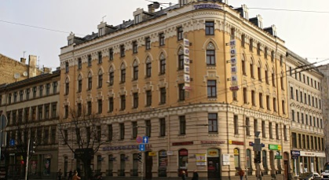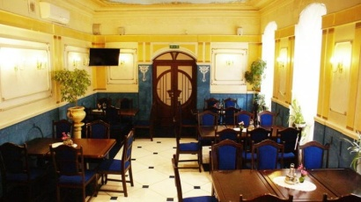

Hotel Dodo***
1 Jersikas Street, Riga, Latvia
Phone: +371 67240219, Fax: +371 67240218
Contact person: Evija Abramcika
E-mail: sales@dodohotel.com
http://www.dodohotel.lv/en/index.html
Special rate: 29.00 € (single room per night, breakfast and VAT included)
For registration, please use booking code: TSI
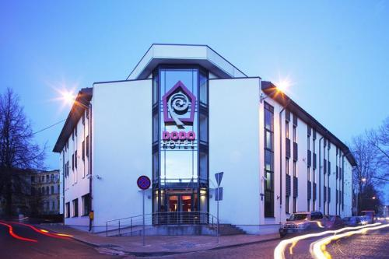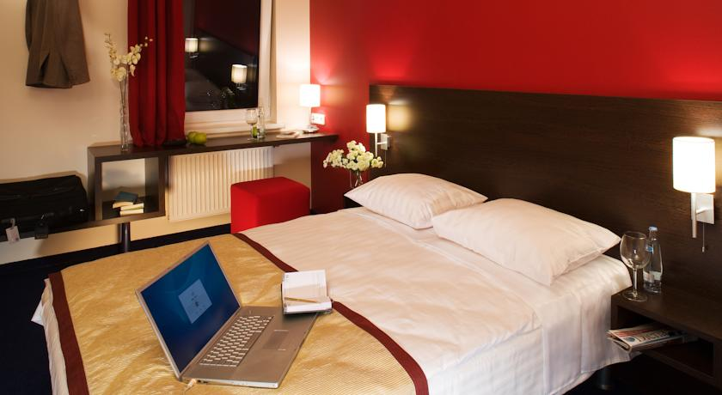

Other options: You can also do your own booking via usual platforms, e.g. http://www.booking.com

How to reach meeting location from every of suggested hotels

By public transport

BELLEVUE Park Hotel Riga

- Approximately 5 minutes by foot from the hotel to the bus stop
- Take a bus No.54 (stop: Stacijas laukums) than approximately 3 minutes by foot to the Central Station. Take a trolley-bus No.15 to Kengarags (stop: Lomonosova Street)
- You just need to cross the street and you will reach the venue. (Please see the map below).
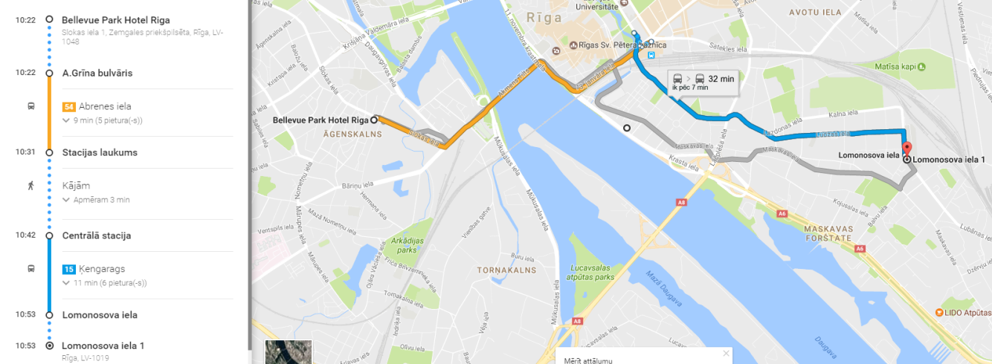

Rixwell Old Riga Palace Hotel
- Approximately 10 minutes by foot from the hotel to the trolley-bus stop
- Take a trolley-bus No.15 (stop: Central Station) to Kengarags (stop: Lomonosova Street)
- You just need to cross the street and you will reach the venue. (Please see the map below).

Europa Royale Riga Hotel
- Approximately 5 minutes by foot from the hotel to the trolley-bus stop
- Take a trolley-bus No.15 (stop: Central Station) to Kengarags (stop: Lomonosova Street)
- You just need to cross the street and you will reach the venue. (Please see the map below).

Pixwell Irina Hotel

- Approximately 4 minutes by foot from the hotel to the trolley-bus stop
- Take a trolley-bus No.15 (stop: Central Station) to Kengarags (stop: Lomonosova Street)
- You just need to cross the street and you will reach the venue. (Please see the map below).

Hotel Dodo

- Approximately 5 minutes by foot from the hotel to the trolley-bus stop
- Take a trolley-bus No.15 (stop: Katolu Street) to Kengarags (stop: Lomonosova Street)
- You just need to cross the street and you will reach the venue. (Please see the map below).

How to use the public transport in Riga

Schemes of the public transport routes could be found on the link below: http://saraksti.rigassatiksme.lv/index.html#schemas/en.

In principle you need only the trolley-buses scheme.

In order to use a public transport in Riga you should have an E-ticket. E-ticket is a universal electronic ticket enabling the use of the most up-to-date and convenient means of payment for public transport services. The example of yellow E-ticket (the picture could be different) could be seen below.

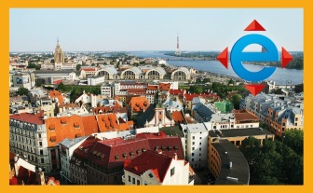

You could purchase E-tickets:
- In ticket vending machines (price depends from ticket type)
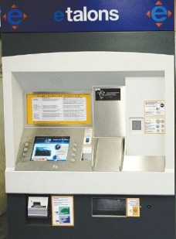

- In “NARVESEN” shop (price depends from ticket type)
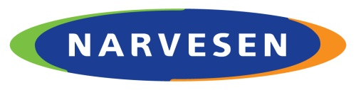

- In public transport from the driver (2.00 EUR)

When entering public transport – bus, trolley-bus or tram, a passenger has to apply a yellow or blue E-ticket at the electronic validator. Thus the trip is registered and the passenger has paid for the trip. Picture of the validator could be seen below:

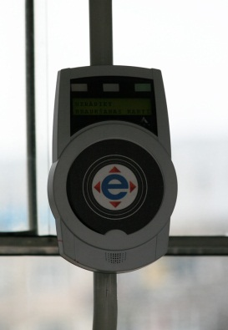

Passengers without a valid or validated ticket are subject to the penalty fare.

